CS 255 System Design Document
DriverPass
Phillip Wesley
DriverPass asked for one online system that customers and employees can use from a computer or phone. Customers need to buy a training package, take practice tests, and manage driving lessons. The secretary, drivers, owner, and IT officer need different tools based on their jobs. This design shows who uses each part, what happens during the main tasks, when the system checks information, and how the records are saved.

UML Diagrams
I used both process and object modeling because each one answers a different question. The activity and sequence diagrams show what happens first, what is checked, and what happens next. Those diagrams do not show every record the system must keep, so the class diagram fills that gap. The use case views connect the people to the work they are allowed to perform.

Use Case Diagram, View 1 of 3
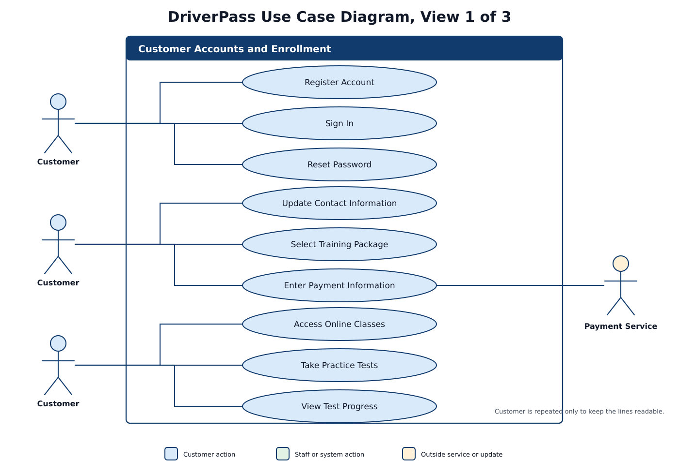
Figure 1. Customer accounts and enrollment view
I divided the 27 use cases into three views, so the connector lines stay readable. This first view shows what a customer can do after opening the DriverPass website: register, sign in, update contact information, choose a package, use the online class, and take practice tests. The Customer actor is repeated only to prevent crossed lines. Payment information goes to an outside payment service, so DriverPass does not keep the raw card number in its own system.

Use Case Diagram, View 2 of 3
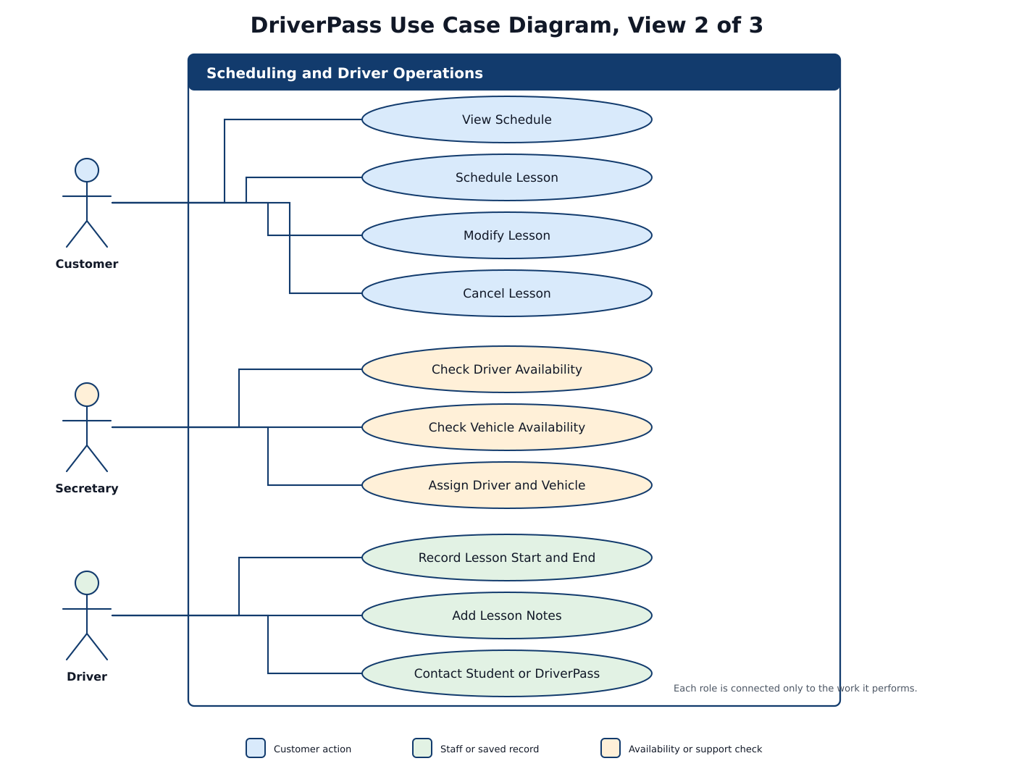
Figure 2. Scheduling and driver operations view
This view covers the daily lesson work. A customer can view, schedule, change, or cancel a lesson online. The secretary can do the same work when a customer calls or visits the office. Before a two-hour lesson is saved, the system checks for both an available driver and an available car. After the lesson, the driver records the actual start and end times, adds notes, and contacts the student when needed.

Use Case Diagram, View 3 of 3
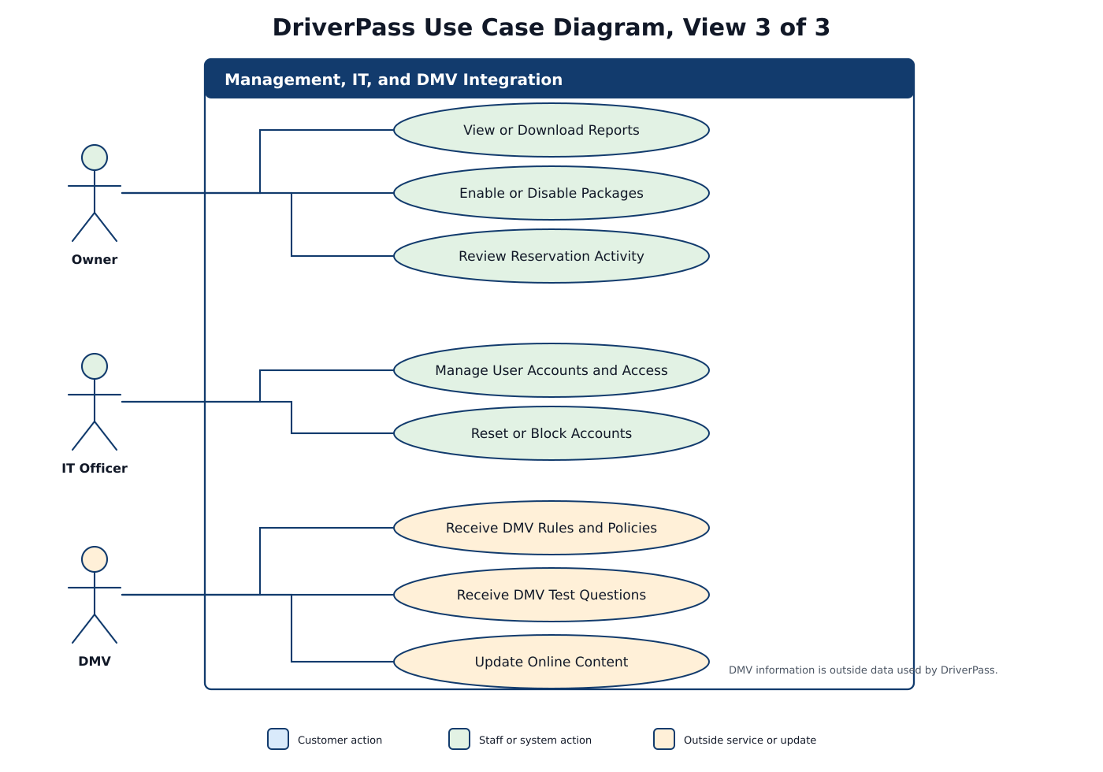
Figure 3. Management, IT, and DMV integration view
This view shows the work handled by management, IT, and the DMV connection. The owner reviews reports and reservation activity and can stop new customers from choosing a package. The IT officer manages access and can reset or block an account when needed. When the DMV sends new rules, policies, or sample questions, DriverPass reviews the update before changing the online material. All three views belong to the same use case model.

Activity Diagram Schedule or Modify a Driving Lesson
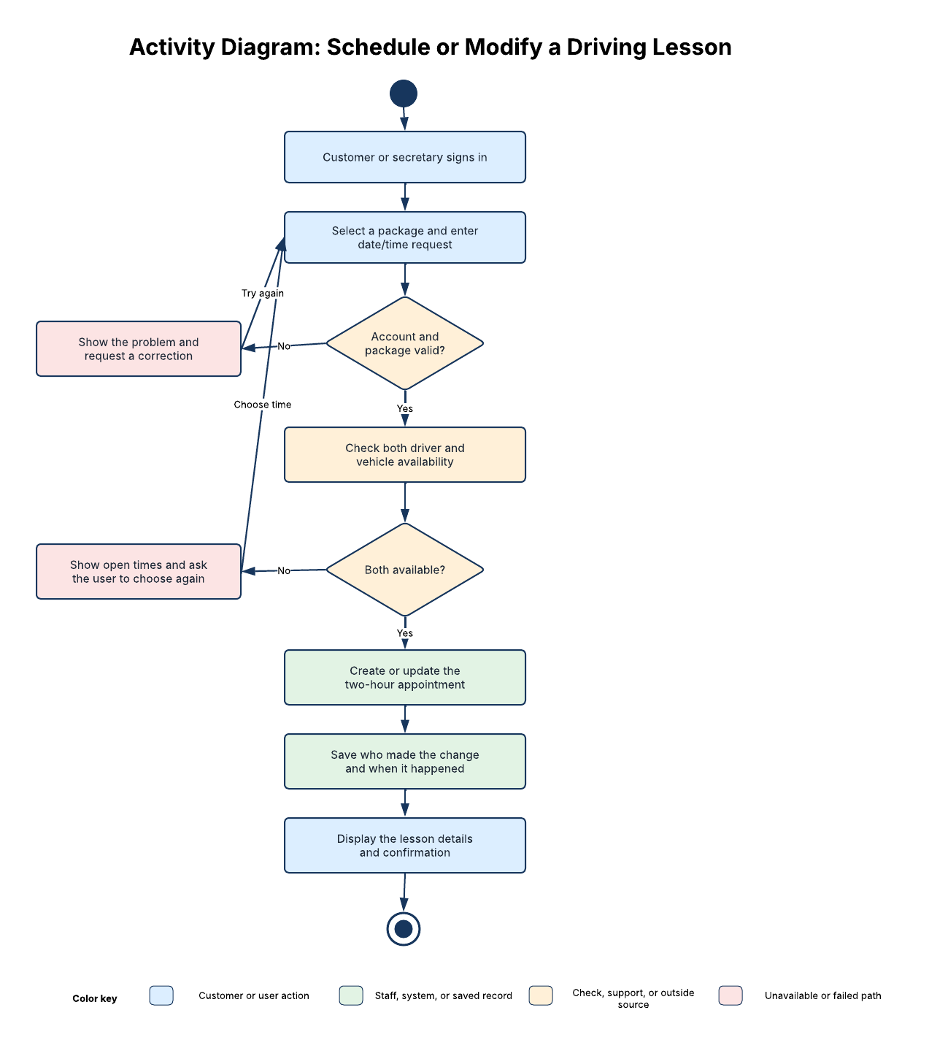
Figure 4. Activity diagram for lesson scheduling
A customer starts this process online, or the secretary starts it for someone who calls or visits the office. After sign-in, the user chooses a package and requests a date and time. DriverPass checks the account and package first, then checks for an available driver and car. If something is wrong, the system explains the problem and asks for another choice. When the request works, it saves the two-hour lesson, records who made the change and when it happened, and shows a confirmation.

Activity Diagram Complete a Practice Test
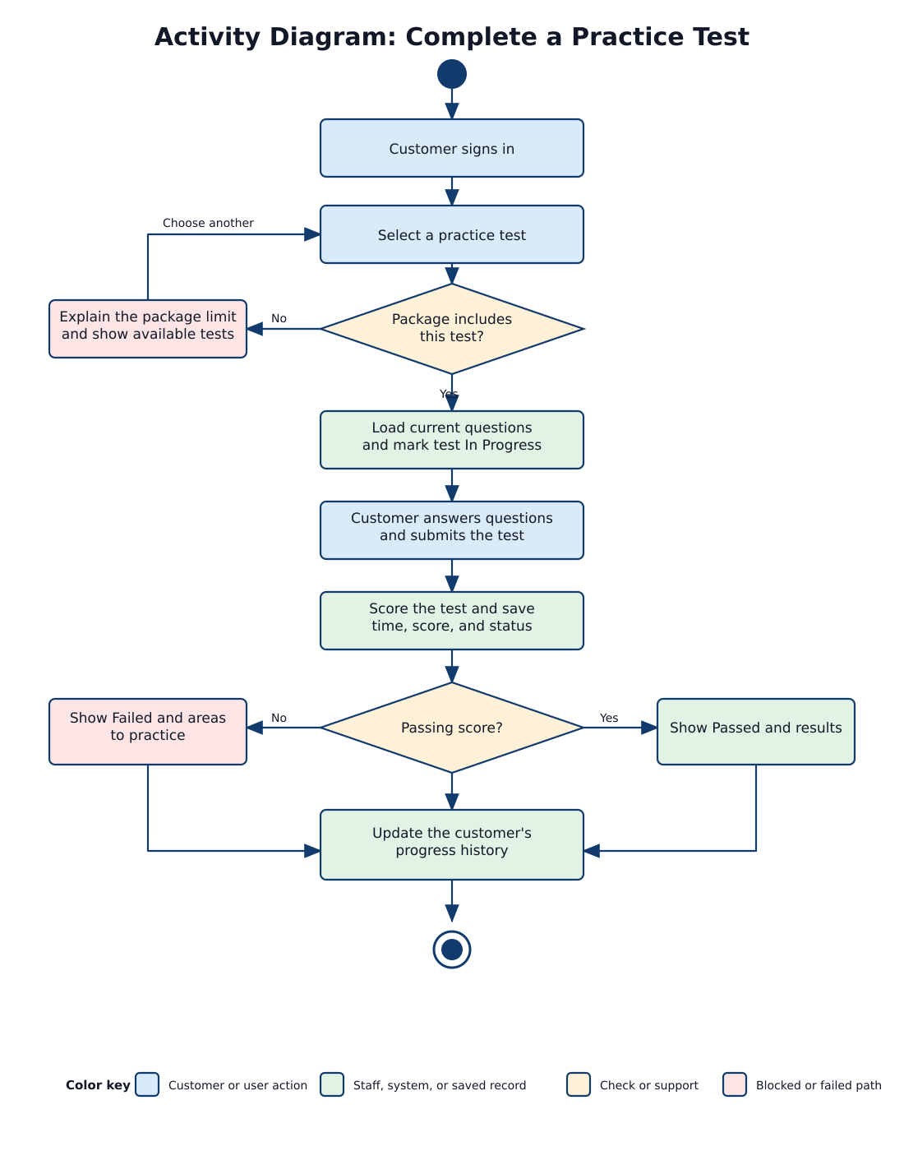
Figure 5. Activity diagram for a practice test
A customer starts a practice test from the online class. Before the questions open, DriverPass checks that the customer's package includes the test. The system marks the test in progress while the customer works, then scores the answers and saves the time, score, and final status. The customer sees a passed result or the areas that need more practice, and the progress history updates either way.

Sequence Diagram Schedule or Modify a Driving Lesson
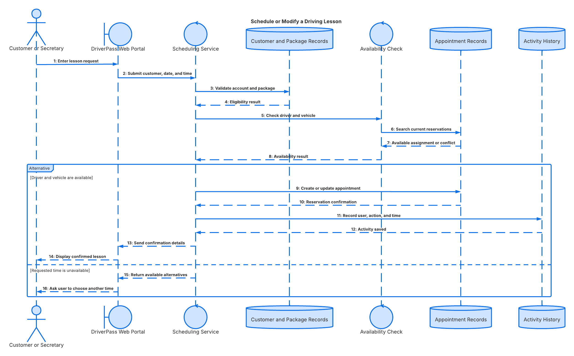
Figure 6. Sequence diagram for lesson scheduling
This diagram uses the lesson scheduling process to show when each part of DriverPass responds. The customer or secretary sends the request through the website. The scheduling service checks the customer and package, then checks the current driver and car reservations. If both are open, the system saves the lesson, records who made the change, and sends a confirmation. If the time is already taken, it returns other choices instead of creating a duplicate booking.

Class Diagram, View 1 of 2
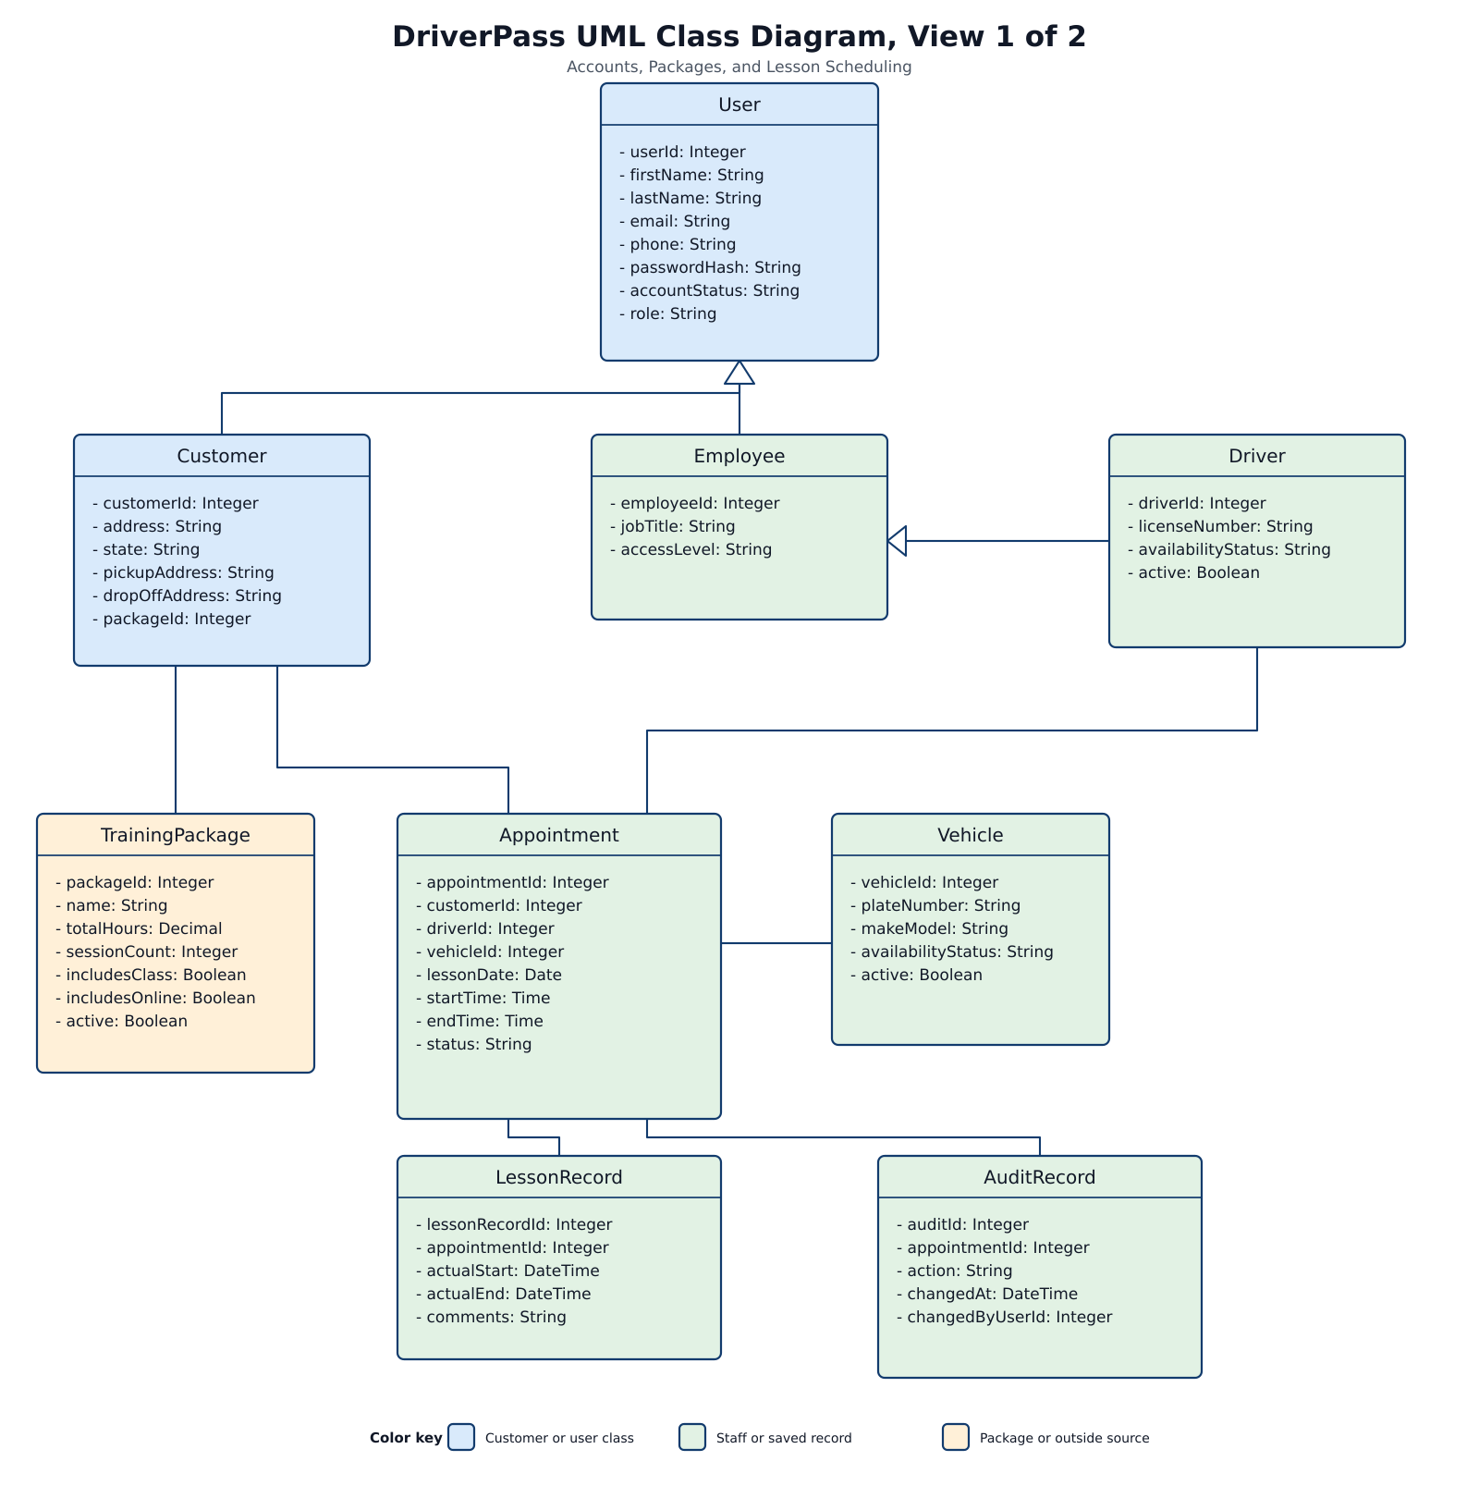
Figure 7. Accounts, packages, and lesson scheduling classes
I divided the class model into two views, so the relationships are easier to follow. This first view shows the information DriverPass must keep for accounts, packages, and driving lessons. Customer, Employee, and Driver all use the basic User account information. Each Appointment stores the customer, driver, car, date, and time. The lesson and audit records show what happened during the lesson and who changed the reservation.

Class Diagram, View 2 of 2
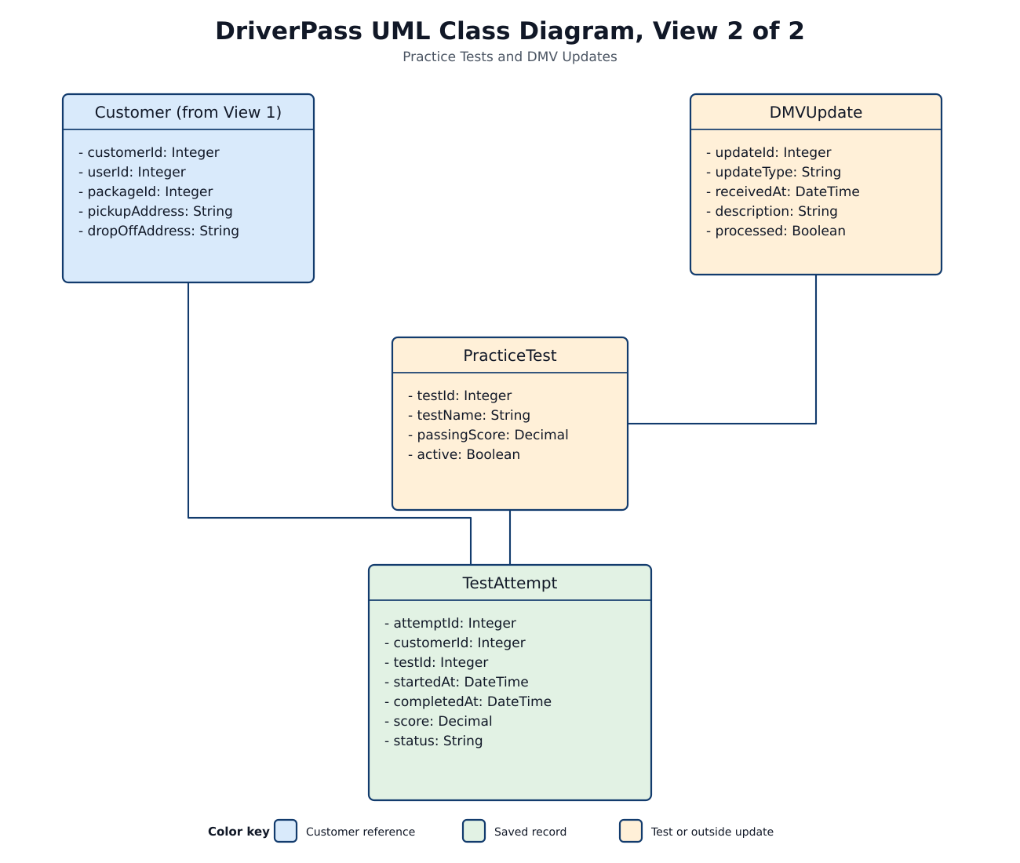
Figure 8. Practice test and DMV update classes
This view shows what DriverPass saves when a customer takes a practice test. DMVUpdate stores the rules or questions received from the agency and whether DriverPass has processed them. PracticeTest holds the approved test information. TestAttempt connects a customer to a test and saves when it started, when it ended, the score, and the status. The repeated Customer box links this view to the account and scheduling view.

Technical Requirements

The DriverPass system needs to support customers, the secretary, drivers, the owner, and the IT officer from one shared online system. Customers should be able to reach the website from home or another location, while employees need access from the office or while completing work away from it. The system must keep appointments, training records, practice test results, and account information in one place, so everyone is working with the same current data. Live changes must happen online because allowing separate offline copies to update the system could create duplicate or conflicting records. The technical design therefore needs the correct hardware, software, development tools, and cloud infrastructure to support the daily work described by DriverPass.

Hardware Requirements

Customers and employees will need a computer, tablet, or phone with a current web browser and a reliable internet connection. Customers can use their own devices to create an account, select a package, take practice tests, and manage driving lessons. The secretary and IT officer will need standard office workstations because their responsibilities involve customer registration, scheduling, account support, and system administration. Drivers should be able to use a supported computer, tablet, or phone to view assigned lessons and enter the actual lesson times and comments after training is completed.

DriverPass currently has ten drivers and ten cars, so the system must also keep an accurate record of those resources and their availability. A customer should not be assigned a lesson unless both a driver and a car are available for the requested two-hour period. DriverPass will not need to maintain an application server in the office because the website and database will be hosted in the cloud. This lowers the amount of equipment that Ian and the DriverPass staff must maintain while still allowing them to access the system from various locations.

Software Requirements

The main software component will be a responsive website that works on supported computers and mobile devices. The same website will provide different screens and options depending on who signs in. Customers will use it for account management, package selection, online classes, practice tests, and lesson scheduling. The secretary will use it to register customers and manage appointments for people who call or visit the office. Drivers will use it to review assigned lessons and record lesson times and comments. The owner will use it to review reports, check reservation activity, and disable a package when DriverPass no longer wants new customers to select it. The IT officer will use it to manage user access, reset accounts, and block accounts when an employee leaves the company.

Behind the website, the system needs application software that processes each request and applies DriverPass’s business rules. For example, when a customer or secretary requests a lesson, the application must confirm that the account and training package are valid before checking the requested date and time. It must then check both driver and vehicle availability before saving the appointment. The driver and car should be reserved together so another customer cannot receive the same resources during that time. If either resource is unavailable, the system should explain the problem and allow the user to choose another time.

A relational database will store the information used by the website and application. It will connect each appointment to the correct customer, driver, vehicle, date, start time, and end time. The database will also store user accounts, training packages, practice tests, test attempts, lesson records, and reservation history. Practice test records must include the test name, time taken, score, and status so customers can see whether a test has not started, in progress, failed, or passed. Reservation history must identify who created, changed, or canceled an appointment and when the action occurred. Keeping these records in one shared database gives DriverPass one current version of the information instead of separate copies that could disagree.

Development Tools

The development team will use Lucidchart to maintain the use case, activity, sequence, and class diagrams. These diagrams give the developers a shared reference for who uses the system, how the main processes work, and what information the database must store. Source control will be needed to track changes to the program code and show who made each change. This also gives the team a way to review updates and return to an earlier working version if a new change causes a problem.

The developers will also need a supported web-development framework, an integrated development environment, tools for controlled database updates, and automated testing tools. Testing should take place before a change is released to DriverPass. The tests should confirm that users receive the correct access, appointments cannot double-book a driver or car, practice-test results save correctly, and reservation changes appear in the activity history. A separate testing environment should be used so developers can check an update without changing live customer records. Changes to the lessons, classes, or tests included in a package will still require a developer or system analyst, although the owner can disable an existing package through the website.

Infrastructure Requirements

The website, application, and database should run through a managed cloud service. Cloud hosting allows customers and employees to reach DriverPass from various locations without depending on a server inside the office. The cloud environment must support secure web connections, so information is protected while it moves between the user’s device and the system. Stored customer, account, and training information must also be encrypted. Passwords should be stored in a protected form instead of readable text, and repeated failed sign-in attempts should temporarily lock the account or alert the IT officer.

The cloud service must provide regular backups and a recovery process in case information is lost, damaged, or changed incorrectly. Backups should run automatically, but DriverPass or the development team should also evaluate the recovery process to confirm that the information saved can be restored. A central system log should record errors, sign-in problems, and important account or reservation activity. Basic performance monitoring will help the IT officer determine when a problem starts and whether it affects the website, application, or database.

The infrastructure must also support the outside services used by DriverPass. Payment information should be sent through a secure payment provider instead of storing complete credit card information in the DriverPass database. When the DMV provides updated rules, policies, or sample questions, the system should notify DriverPass that new information is available. DriverPass should review that information before it changes the online class or practice tests. This prevents an outside update from automatically changing material that customers are already using.

Reports should be available through the live system and in a format that the owner can download and open them in Excel. Downloaded reports can be reviewed without an internet connection, but they will only represent the information available when the file was created. Changes made to an offline report will not update the live DriverPass database or appointment schedule. Any action that creates, changes, or cancels live information will require an internet connection so customers and employees continue working with the same current records.

Known Limits
• The system needs an internet connection for live changes. Downloaded reports can be viewed offline, but they cannot update the schedule.
• The owner can turn a package on or off, but changing package modules still requires developer work.
• DMV updates depend on the information and timing provided by the outside agency.
• Lesson availability is limited by the ten drivers and ten vehicles DriverPass currently has.

